Synoptic Meteorology I

**Lab 6: Geostrophic Balance**

Wednesday October 19th, 2022

Name:­­­­­­­ ________________________________________________________________

Due: October 26th, 2022, at 2:30pm

**Objectives**:

* Understand the forces comprising geostrophic balance and how to assess geostrophic balance on isobaric charts.
* Identify situations that result in ageostrophic flow.
* Infer accelerations/air parcel motion in regions of ageostrophic flow.

**Things to know:**

Feel free to use the Internet and collaborate with your colleagues when answering these questions. For Parts I and II, the requested plots must be obtained using the Jupyter Notebook on our JupyterHub before you can complete the questions. Be sure to review the concepts covered in these tutorials rather than just complete the tasks they require as you may be asked to use these concepts in a future lab.

**Part I:** **Estimating the Geostrophic Wind (40 pts)**

Geostrophic flow occurs when the horizontal pressure gradient force and the Coriolis force are balanced, meaning that no other forces are sufficiently large in magnitude to influence the wind speed and direction. The equation for geostrophic flow in the natural coordinate system is:

$$V_{g}= -\frac{1}{f}\frac{∂Φ}{∂n} , where the geopotential Φ=gz$$

After subbing in the geopotential, the magnitude of the geostrophic wind can be approximated by the equation:

$$\left|V_{g}\right|= \frac{g}{f}\frac{Z_{n+1}-Z_{n-1}}{2∆n}$$

Where $f=2Ωsinφ$

and $Ω=7.292 x {10}^{-5} s^{-1}$ and $φ=latitude in degrees$ and $g=9.81 m/s^{2}$

and $Δn=change in distance (m)$

The values *Zn+1* and *Zn-1* represent *Z* at points along the positive and negative *n*-axis, respectively.

1. Complete Part I of the Jupyter Notebook. (10 pts)
2. Using the map you created in Part I of the Jupyter Notebook, approximate the magnitude of the geostrophic wind speed at the three locations marked A, B, and C. After doing so, compare the geostrophic wind speed that you calculated to the observed wind speed at each location. (Show all work.)

Use the following tips to help you with your calculations:

* 1. Determine ΔZ by centering a 1.5 cm long line over each location so that the line is perpendicular to the contours. Estimate the geopotential height at each end of the line and calculate the difference (ΔZ). (7.5 pts)
  2. The value for Δ*n* can be calculated using the fact that the distance between the southern and northern border of North Dakota is ~340 km apart. (7.5 pts)

1. Calculate the percentage difference between the geostrophic and observed wind speeds $\left(\left|\frac{V_{g}- V_{obs}}{V_{g}}\right| x 100\%\right)$ at each location. Note: to convert the geostrophic wind speed to kt, note that 1.94 kt = 1 m s-1. (Show all work; 15 pts)

**Part II: Departures from Geostrophic Balance (60 pts)**

It is convenient to assume that the synoptic-scale flow is geostrophic. However, it is also important to understand where atmospheric flow deviates from being geostrophic. The full horizontal wind vector can be separated into a geostrophic component (due to the Coriolis-pressure gradient balance) and an ageostrophic component (due to processes that cause the observed wind to deviate from the geostrophic approximation).

$$\left(1\right) \vec{V}=\vec{V_{g}}+\vec{V_{a}}$$

Substituting equation (1) into the horizontal momentum equation, we have:

$$\left(2\right) \frac{D\vec{V}}{Dt}=-f\hat{k} × \vec{V}-∇Φ=-f\hat{k} × \left(\vec{V_{g}}+\vec{V_{a}}\right)-∇Φ=-f\hat{k} × \vec{V_{a}}-(f\hat{k} × \vec{V_{g}}+∇Φ)$$

Recall the definition of the geostrophic wind (which always points to the left of the pressure gradient):

$$\left(3\right) \vec{V_{g}}=\frac{\hat{k}}{f}× ∇Φ$$

If we plug (3) in for $\vec{V_{g}}$ in (2), that term becomes:

$$f\hat{k} × \left(\frac{\hat{k}}{f}×∇Φ\right)=0$$

As a result, (2) becomes:

$$\left(4\right) \frac{D\vec{V}}{Dt}= -f\hat{k}×\vec{v_{a}}$$

We can interpret (4) using the right-hand rule. First, point your finger downward – the negative $\hat{k}$ direction, since there is a leading *-f* on this term. Next, point your middle finger in the direction to which the ageostrophic wind is blowing. The resulting direction in which your thumb is pointing represents the direction in which the acceleration vector is pointing.

If we take $\frac{\hat{k}}{f}×(4)$, we obtain an expression for the ageostrophic wind:

(5) $\vec{V_{a}}= \frac{\hat{k}}{f} × \frac{D\vec{V}}{Dt}$

Given the definition of the cross-product, (5) indicates that the ageostrophic wind is perpendicular and to the left of the acceleration vector.

Terms to know:

*Subgeostrophic*: observed wind is *slower* than the geostrophic wind.

*Geostrophic*: observed wind is *equal* to the geostrophic wind.

*Supergeostrophic*: observed wind is *faster* than the geostrophic wind.

***Departures from geostrophic balance: curved flow***

An ageostrophic component of the wind is introduced in curved flow by the *centrifugal force*.

1. Complete Part II of the Jupyter Notebook. (12.5 pts)
2. Recall your comparisons of $V_{g}$ and $V_{obs}$ from Part I. How does the magnitude of the geostrophic wind compare to the observed wind? Is the observed wind subgeostrophic, geostrophic, or supergeostrophic? (7.5 pts)
3. Using the maps you created for October 28, 2021, is the ageostrophic wind at the trough and ridge consistent with what you would expect at each location? Why or why not? (20 pts)

***Departures from geostrophic balance: jets and jet streaks***

The ageostrophic wind is non-zero in jet entrance and exit regions, where the horizontal wind accelerates (entrance region) or decelerates (exit region) following the motion.

1. Using the maps you created for February 3, 2022, is the orientation of the ageostrophic wind in the jet entrance and exit regions consistent with what you would expect there? Why or why not? (20 pts)

**Part IV: Introduction to Ageostrophic-Wind–Induced Vertical Motions (Graduate Students Only; 10 pts)**

In a few weeks’ time, we will introduce the concept of *divergence*. Divergence relates to horizontal changes in wind speed and/or direction. When air is spreading apart, either by becoming faster or by moving in different directions, the flow is said to be divergent. When air is coming together, either by becoming slower or by moving toward a common location, the flow is said to be convergent. An example for flow becoming faster or slower is given below:

We will find, however, that the entire flow (geostrophic plus ageostrophic) is not divergent. Rather, the geostrophic component is inherently non-divergent, leaving only the ageostrophic component to be divergent or convergent. Thus, analyses of ageostrophic flow can help us to infer divergence.

Furthermore, in a few weeks’ time, we will introduce the relationship between divergence and vertical motion. Specifically, vertical motion is inversely proportional to the integrated divergence in a vertical column extending upward from the surface: net integrated convergence (negative divergence) to a vertical level facilitates upward motion (ascent) at that level, whereas net integrated divergence to a vertical level facilitates downward motion (descent) at that level.

For example, consider the case of divergent ageostrophic winds at 300 hPa, near the tropopause (which we assume to be a rigid upper bound on tropospheric vertical motions). When divergence is present, air is being directed away from a location and must be replaced from somewhere. Since the tropopause is a rigid upper bound, the air cannot be replaced from above. Thus, the air must be replaced from by air from below, implying ascent below 300 hPa. The opposite is true when there is convergence at 300 hPa: air is accumulating at a location and cannot be redirected upward, thus it must sink (implying descent below 300 hPa).

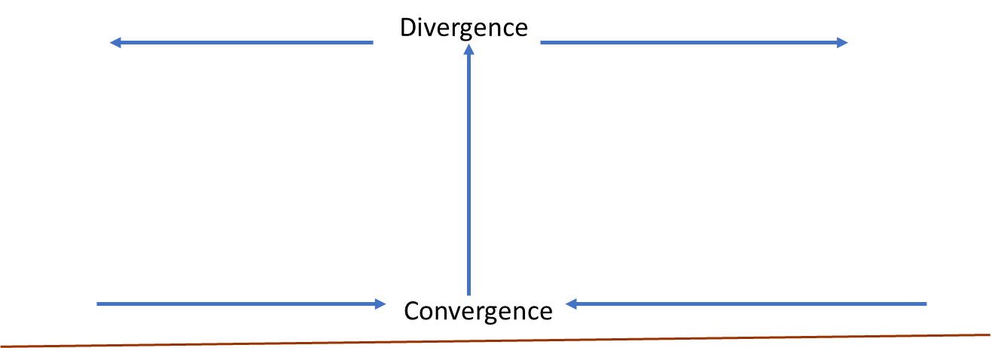

1. Using the ageostrophic wind map you created for February 3, 2022, identify areas of upward vertical motion and sinking vertical motion around the jet streak over the Great Lakes. (5 pts)
2. If sufficient moisture is present for rising air to become saturated, in which areas would you expect to see precipitation? (5 pts)